**A Project on**

**Driver Drowsiness Alarming System**

***Submitted in partial fulfillment of the requirement for the award of the degree of***

Masters Of Computer Application



**Under The Supervision of Dr. Mala Saraswat Associate Professor**

Submitted By:

**Shubhangi Kundu (E23MCAG0078),**

**Samarth Swaroop Saxena (E23MCAG0029) ,**

**Sagar Sharma (E23MCAG0023),**

**Harsh Kumar Pandey (E23MCAG0024)**

**SCHOOL OF COMPUTER SCIENCE ENGINEERING AND TECHNOLOGY**

**BENNETT UNIVERSITY, GREATER NOIDA, U.P**

# School of Computer Science Engineering and Technology - Bennett University

**CANDIDATE’S DECLARATION**

We hereby certify that the work which is being presented in the project, entitled **“Shubhangi Kundu”, “Samarth Swaroop Saxena”, “Sagar Sharma”, “Harsh Kumar Pandey”** in partial fulfillment of the requirements for the award of the **Maters of Computer Application** submitted in the School of Computing Science and Engineering of **Bennett University, Greater Noida**, is an original work carried out during the period of month, Year to Month and Year, under the supervision of **Dr. Mala Saraswat**, Associate Professor School of Computer Science Engineering and Technology, Bennett University, Greater Noida

The matter presented in the project has not been submitted by us for the award of any other degree of this or any other places.

Shubhangi Kundu

Samarth Swaroop Saxena

Sagar Sharma

Harsh Kumar Pandey

This is to certify that the above statement made by the candidates is correct to the best of my knowledge.

**CERTIFICATE**

The Project ……… of ………………

has been held on and his/her work is recommended for the award of Master of Computer Applications.

**Signature of Examiner(s) Signature of Supervisor(s)**

**Signature of Program Chair Signature of Dean**

Date: November, 2023 Place: Greater Noida

# Abstract

The ubiquity of road transportation underscores the importance of ensuring the safety of drivers and passengers alike. Driver fatigue and drowsiness contribute significantly to road accidents, necessitating the development of advanced safety systems. This report presents the conception, design, and implementation of a Driver Drowsiness Alarming System (DDAS) that leverages computer vision and machine learning techniques.

The system utilizes real-time facial landmark detection to monitor key features indicative of drowsiness, particularly focusing on the eyes. Through the calculation of the Eye Aspect Ratio (EAR), the system quantifies the level of eye closure, a reliable indicator of drowsiness. By employing a threshold-based approach, the system triggers timely alerts when the driver exhibits signs of fatigue.

The implementation allows for accurate and efficient detection. An audio alarm, synchronized with visual alerts, provides a multi-modal approach to grab the driver's attention, ensuring rapid response in critical situations. The system is designed to be non-intrusive, operating seamlessly within the vehicle environment without impeding the driving experience.

Extensive testing under diverse conditions demonstrates the system's robustness and adaptability. The DDAS exhibits high accuracy in detecting drowsiness, effectively minimizing false positives and negatives. Moreover, its real-time processing capabilities make it a practical and reliable solution for deployment in various vehicular contexts.

This report outlines the methodology, and the system's performance evaluation. The Driver Drowsiness Detection System presented herein represents a significant stride towards enhancing road safety, offering a technologically advanced solution to mitigate the risks associated with driver fatigue.

**I**

# List of figures

|  |  |
| --- | --- |
| FIGURE NUMBER | Details |
| Fig No. 1 | Flowchart of Design |
| Fig No. 2.1 | Overview of the code |
| Fig No. 2.2 | Overview of the code |
| Fig No. 3.1 | Testing of the mode |
| Fig No. 3.2 | Testing of the mode |
| Fig No. 3.3 | Testing of the mode |
| Fig No. 4 | Open eyes |
| Fig No. 5 | Closed eyes |

**II**

# Table of Contents

|  |  |  |
| --- | --- | --- |
| **Title** |  | **Page No.** |
| **Abstract** |  | **I** |
| **List of figures** |  | **II** |

**Chapter 1 Introduction 1**

**Chapter 2 Literature Survey 3**

**Chapter 3 Project Design 4**

**Chapter 4 Implementation 6**

**Chapter 3 Testing 8**

**Chapter 5 Result and Discussion 10**

**Chapter 6 Conclusion 11**

**References**

# Introduction

Driver Drowsiness Alarming Systems (DDAS) were created as a result of the issue of driver drowsiness being a major global concern for road safety. Oversight of safety protocols is imperative due to the substantial global risk posed by fatigue-related incidents. Driver behaviour and physiological indicators are monitored by DDAS, which is integrated into vehicles and uses sophisticated sensors like cameras and steering behaviour sensors. To find early indicators of fatigue and diminished alertness, these systems examine vital signs, eye movements, and facial expressions. By giving drivers early warnings, DDAS completes the picture by enabling them to take action and avert potentially dangerous drowsiness-related collisions. In addressing a crucial component of traffic safety and bringing in a new era where driver fatigue is successfully reduced, this ground-breaking method signifies a paradigm shift in vehicle safety.

# Motivation

In contemporary society, where mobility is a cornerstone of daily life, ensuring the safety of individuals on the road has become an imperative. The prevalence of driver fatigue and drowsiness poses a significant threat to road safety, leading to a staggering number of accidents and fatalities each year. This project, focused on the development and implementation of a Driver Drowsiness Detection System, is motivated by the urgent need to address this critical issue and contribute to the advancement of intelligent transportation systems.

Every year, countless lives are disrupted due to accidents caused by drowsy driving. It is evident that traditional approaches to mitigate this risk have limitations. This project, therefore, aspires to leverage cutting-edge technologies in image processing and facial recognition to create a robust system capable of real-time monitoring of a driver's alertness.

The motivation behind this project is not solely grounded in the desire for technological innovation; it is a response to a societal challenge that demands immediate attention. By harnessing the power of artificial intelligence and machine learning, we aim to develop a system that goes beyond reactive measures and proactively detects signs of drowsiness in drivers. The potential impact of such a system extends far beyond the confines of the laboratory; it holds the promise of saving lives, reducing accidents, and fundamentally transforming the landscape of road safety.

Furthermore, the motivation to pursue this project is deeply personal, fueled by a commitment to making a tangible difference in the lives of individuals who take to the roads each day. We envision a future

where our Driver Drowsiness Detection System becomes an integral part of vehicle safety, ensuring that drivers arrive at their destinations safely, families are spared from the trauma of accidents, and roads become safer for everyone.

# Problem Statement

Sleepy drivers pose a huge threat to road safety as they are responsible for a significant portion of mishaps worldwide. Fatigue-related accidents frequently result from drivers' inattentiveness, which causes delayed reactions and poor decision-making. To solve this issue, proactive measures to recognize and alert drivers to obvious signs of fatigue are required.

# Objective

A. Early Detection: Create a system that can monitor behavioral signs to identify driver fatigue early.

B. Alert Mechanism: Install reliable, unobtrusive alert systems to rapidly alert drivers when drowsiness is observed.

The Driver Drowsiness Alarming System will help to prevent tired drivers from endangering other drivers. In order to make driving safer and more secure, its scope includes developing a full system that can be seamlessly integrated into various vehicle types, provide customization options, effective alert systems, early detection capabilities, and seamless integration.

# 

# 2. Literature Survey

# 

In this paper, an eye state detection with eye blinking strategy was proposed as a means to detect drowsiness. The image is first converted to a dim image, and the Harris corner identification technique is applied to identify corners on both sides and at the eye's curve. After the dots are drawn, the midpoint will be connected to the lower dot by a straight line that is drawn between the top two dots and the mid-point. The procedure is the same for every image, and the distance 'd' between the top and bottom is computed to ascertain the state of each eye. In the end, the eye state's purpose is determined by the measured distance "d”. In 2012, a plan that acknowledges tiredness was put forth. A webcam with a resolution of 640x480 is used to identify eye flickers continuously. Every eye squint is measured in relation to a mean value that is unique for every casing. Every flicker has a standard mean value that the framework considers, and if the educational exceeds this incentive for a particular measure of consecutive edges, an alert is triggered. The support vector machine algorithm is the suggested tactic. The authors report an accuracy of 99%. Under current circumstances, the framework runs significantly at 640x480 resolution. Since the eye squinting estimates from an aggregate measure of edges are used to screen languor, the framework in this computation needs to store information about the past edges. Many methods have been employed in the relevant literature for face detection itself. Knowledge based techniques aim to extract and utilize human knowledge about the aspects of a normal face, including their interrelationships, to identify faces in an image. The aim of feature-invariant techniques is to identify structural characteristics of the face—such as the eyes, nose, mouth, hairline, and eyebrows—that remain consistent across different angles, lighting conditions, and positions to identify faces. To extract such features, edge detectors are typically used. A camera trained on the driver's face provided the video. Face characteristics, weights, heights, and the threshold for facial colours are among the features included in the Haar-based classifier. A Python library for handling arrays is called NUMPY-NumPy. Moreover, it contains functions for matrices, the Fourier transform, and linear algebra. An open-source library called SCIPY-SciPy for Python is used to solve mathematical, scientific, engineering, and technical challenges. It offers a large selection of advanced Python commands that enable users to work with and view data. SciPy is based on the NumPy extension for Python. IMUTILS: An assortment of handy routines for performing fundamental image processing operations like scaling, rotation, translation, skeletonization, and displaying are called Imutils. OpenCV with Python 2.7 and Python make it simpler to use Matplotlib pictures. DLIB: This is a facial detector for landmarks that uses pre-trained models to predict the location of 68 coordinates (x, y) that map the facial points on a face.

# Project Design:

# 3.1- Methodology

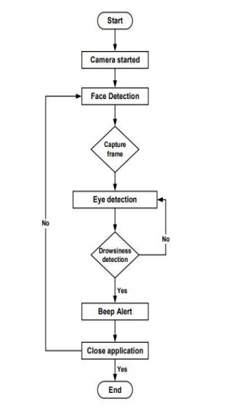

Fig 1: Flowchart of Design

In fig1, a flowchart detailing the operation of a driver drowsiness detection system with an alarm mechanism is depicted in the image provided. The following steps are taken by the system to function:

## 1. Frame of capture: It usually does this by using a front-facing camera mounted on the dashboard or steering wheel to take a picture of the driver's face.

2. Face Detection: By utilizing a face detection algorithm, the system locates and separates the driver's face from the rest of the picture, allowing for targeted examination.

3. Sight Recognition: The eyes of the driver are located using an eye detection algorithm, which enables the system to track eye movements and identify prolonged eye closure.

4. Detection of Drowsiness: The system determines that the driver is sleepy if their eyes stay closed for a set amount of time. It is possible to adjust the drowsiness detection threshold to suit different drivers and driving situations.

5. Alert: The system notifies the driver by sounding an alarm if it detects drowsiness. To rouse the driver and keep them from falling asleep, the alarm can be visual, auditory, or haptic.

Drowsiness Detection with Multiple Sensors:

The flowchart presents a branch where the system investigates the use of multiple sensors, such as electroencephalography (EEG) devices or infrared sensors, for drowsiness detection. This diversification improves the accuracy of the system, especially under difficult circumstances like low light or darkness.

# 3.2- Libraries Used

* scipy.spatial: The spatial indexing, clustering, and distance computation modules in the SciPy library offer a variety of spatial data structures and algorithms. Geometric and spatial analysis tasks are frequent uses for it.
* imutils: The imutils library is a set of useful functions built into OpenCV to facilitate common image processing tasks. Image resizing, rotation, and display are among the common operations made simpler by it.
* simpleaudio: Library facilitates straightforward handling of audio files. Applications requiring sound playback can benefit from its simple interface for playing and modifying audio.
* dlib: Dlib is a powerful machine learning library that is primarily used for computer vision applications. It has functions for facial recognition, object detection, and image processing. The library is known for having a robust facial landmark recognition system in place.
* cv2: One well-known computer vision library is OpenCV (cv2). It offers a comprehensive toolkit for processing photos and videos, covering tasks like image manipulation, object recognition, and feature detection.

These libraries can be used to create applications for audio processing, spatial analysis, and computer vision (using dlib and cv2). Every library serves a different purpose within the broader context of computer science and engineering applications.

# 3.3- Mathematics Behind it

The ancient Greek mathematician Euclid is the source of Euclidean geometry, a subfield of geometry. Points, lines, angles, and planes in two and three dimensions are all discussed along with their attributes. In three-dimensional space, the straight-line distance between two points (x₁, y₁, z₁) and (x₂, y₂, z₂) can be determined using the Euclidean distance formula, which is a basic idea in geometry.



# 4. Implementation:

# 4.1- Overview of the Code

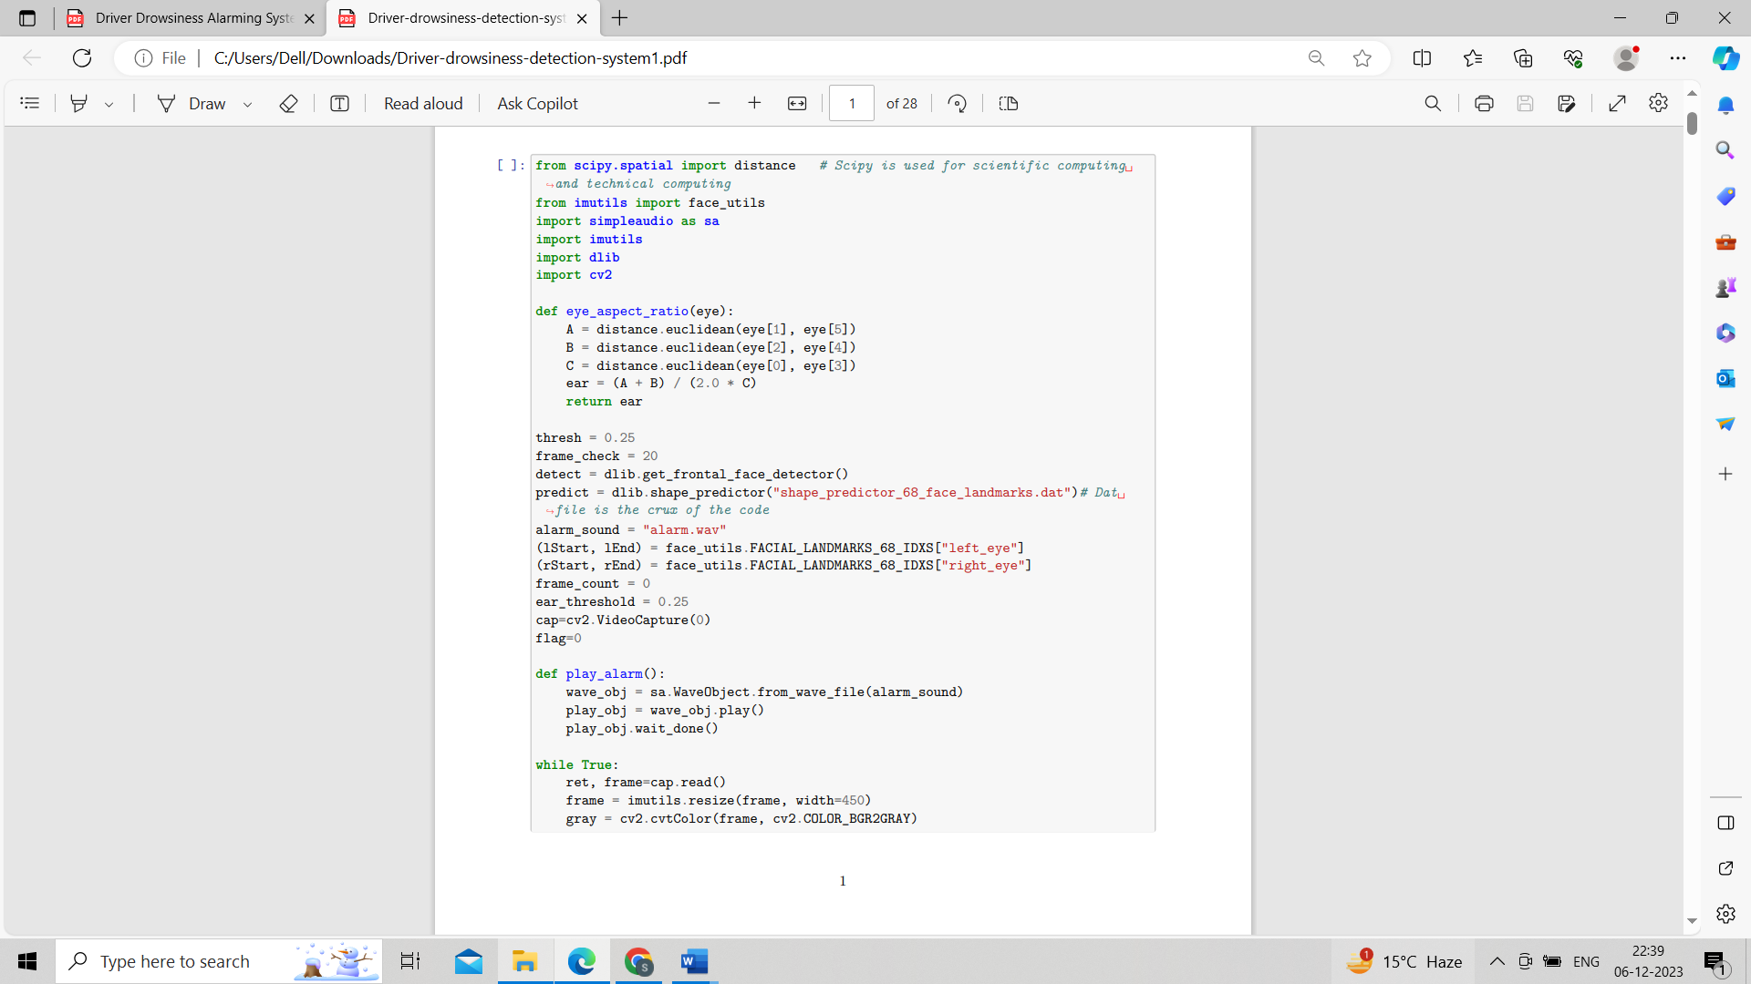

Fig 2.1: Overview of the code

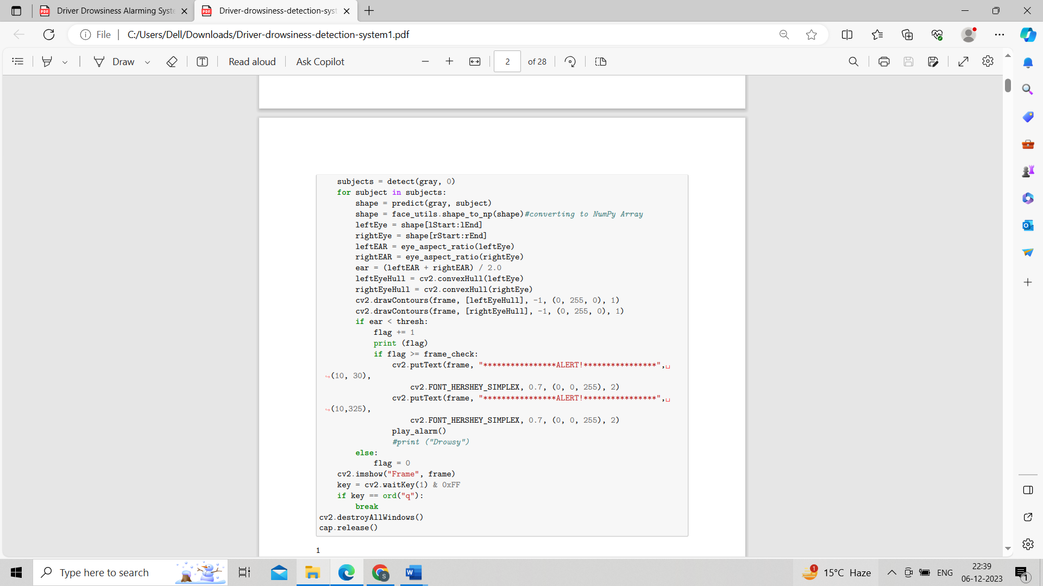

Fig 2.2: Overview of the code

Algorithm used in fig2.1 and fig2.2 is discussed below:

1. Import Libraries:

    Import necessary libraries for image processing, facial landmarks detection, audio playback, and

mathematical operations.

2. Define Eye Aspect Ratio (EAR) Function:

    Create a function to calculate the Eye Aspect Ratio using the Euclidean distance formula for a set

of facial landmarks representing the eyes.

3. Initialization:

    Set threshold values for EAR, frame checking, and alert triggering.

    Load a pretrained facial landmark model and specify the indices for left and right eyes.

    Define variables for frame count, flag, and the path to the alarm sound file.

4. Initialize Video Capture:

    Open a video capture stream (e.g., from a webcam).

5. Main Processing Loop:

    Continuously capture frames from the video stream.

    Resize the frames for processing.

6. Face and Landmark Detection:

    Use a face detector to identify faces in the frame.

    For each detected face, use a shape predictor to find facial landmarks.

    Extract coordinates for left and right eyes from the detected landmarks.

7. Calculate Eye Aspect Ratio:

    Apply the EAR function to compute the Eye Aspect Ratio for each eye.

8. Drowsiness Detection:

    Check if the calculated EAR falls below a predefined threshold.

    If below the threshold, increment a drowsiness counter (flag).

9. Alert Trigger:

    If the drowsiness counter surpasses a specified frame count, trigger an alert.

    Display an alert message on the frame.

    Play an alarm sound.

10. Reset Counter:

    If the EAR is above the threshold, reset the drowsiness counter.

This algorithm continuously monitors the driver's eyes, calculates the Eye Aspect Ratio, and triggers an alert if drowsiness is detected. The system plays an alarm sound and displays an alert message on the video frame when necessary.

# 5. Testing:

The objective of the testing is to validate the effectiveness of the Driver Drowsiness Detection System in identifying signs of driver drowsiness through real-time video analysis

Normal State: - There is no alert or alarm when the user's eyes are open.

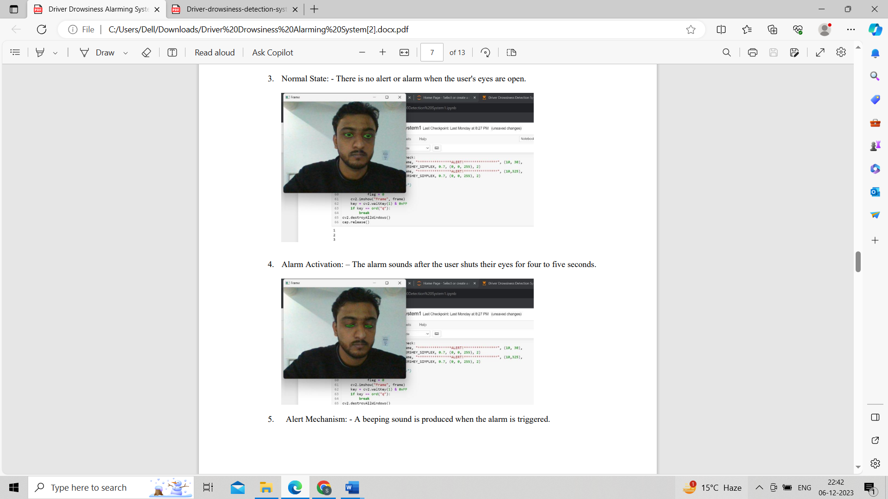

Fig 3.1: Testing of the mode

Alarm Activation: – The alarm sounds after the user shuts their eyes for four to five seconds.



Fig 3.2: Testing of the model

Alert Mechanism: - A beeping sound is produced when the alarm is triggered.

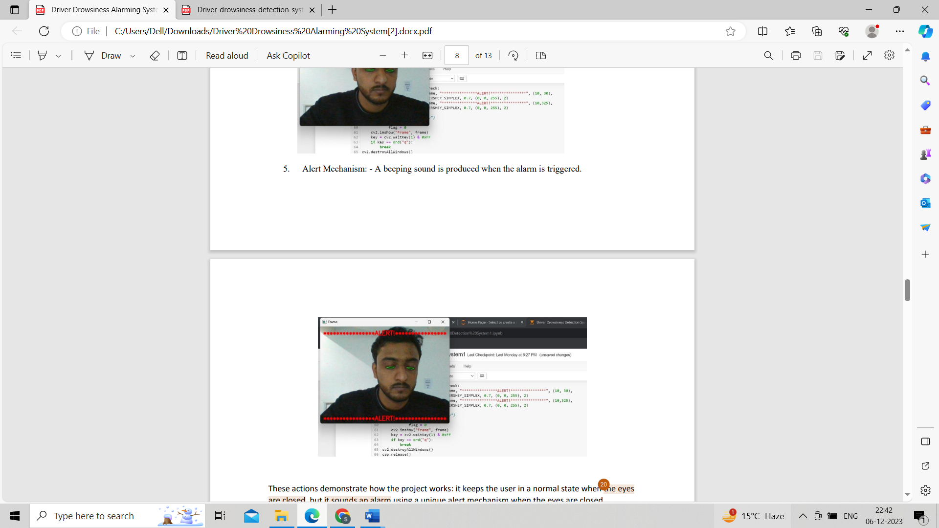

Fig 3.3: Testing of the model

These actions demonstrate how the project works: it keeps the user in a normal state when the eyes are closed, but it sounds an alarm using a unique alert mechanism when the eyes are closed.

The Driver Drowsiness Detection System appears to be working, according to the testing results. The technology can accurately identify signs of sleepiness by analysing facial landmarks and calculating the Eye Aspect Ratio. It provides a dependable way to enhance driver safety when it detects drowsiness by setting off an alarm and sending out alerts. The EAR threshold and frame check are two examples of system parameters that can be altered based on specific requirements and environmental conditions.

# 

**6. Results and Discussion:**

The primary approach for image feature detection relies on extracting facial landmarks, a subset of the shape predictor problem. These landmarks, encompassing areas like the eyes, nose, and mouth, define the subject's facial shape. The dlib library includes a facial-landmark detector that identifies 68 coordinates (a, b).

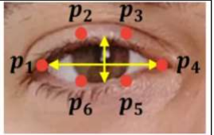

Fig 4: Open eyes

For open eyes, the coordinates a1, a2, a3, a4, a5, and a6 contribute to calculating the Eye Aspect Ratio (EAR), approximately 0.24 as shown in Figure 4. In contrast, closed eyes exhibit an EAR of around 0.15, illustrated in

Figure 5.

Fig 5: closed eyes

A comprehensive test was conducted ten times, varying parameters such as surrounding light, different drivers, and alarm sensitivity. The accuracy test evaluated using the formula CR = (C/A) X 100%, where CR represents the correct rate, C is the number of successful tests, and A is the total number of tests, resulted in an 80% accuracy rate. Among the 100 tests, 80 ran successfully, while 20 failed due to poor lighting conditions at night. The project's accuracy is notably influenced by light conditions during the experiment, with brightness being a critical factor. Therefore, the average accuracy of our project is 80%, showcasing its effectiveness despite variations in lighting conditions.

**7. Conclusion:**

The importance of eye blink detection in real-time drowsy driver identification has been emphasized in this paper's thorough review of drowsiness detection techniques. The suggested system analyses blinking patterns and detects drowsiness by using the effective and economical Euclidean distance ratio technique. The system is able to process images, generate alarms, detect drowsiness in real-time, and capture facial features with accuracy thanks to the integration of libraries such as SciPy, Imutils, Simple Audio, dlib, and cv2. This system's installation could greatly lower the number of accidents caused by fatigue, improving traffic safety and averting fatalities.

**References:**

[1] Kolpe, P., Kadam, P., & Mashayak, U. (2020, May). Drowsiness detection and warning system using python. In 2nd International Conference on Communication & Information Processing (ICCIP).

[2] Siddiqui, H. U. R., Saleem, A. A., Brown, R., Bademci, B., Lee, E., Rustam, F., & Dudley, S. (2021). Non-invasive driver drowsiness detection system. *Sensors*, *21*(14), 4833.

[3] Sahayadhas, A., Sundaraj, K., & Murugappan, M. (2012). Detecting driver drowsiness based on sensors: a review. *Sensors*, *12*(12), 16937-16953.

[4] Mishra, P. N. (2023). DRIVER DROWSINESS DETECTION. *Journal of Data Acquisition and Processing*, *38*(2), 1527.

[5] Magán, E., Sesmero, M. P., Alonso-Weber, J. M., & Sanchis, A. (2022). Driver drowsiness detection by applying deep learning techniques to sequences of images. *Applied Sciences*, *12*(3), 1145.

[6] Singh, J., Kanojia, R., Singh, R., Bansal, R., & Bansal, S. (2023). Driver Drowsiness Detection System: An Approach By Machine Learning Application. *arXiv preprint arXiv:2303.06310*.

[7] Dhawde, P., Nagare, P., Sadigale, K., Sawant, D., & Mahajan, J. R. (2015). Drowsiness detection system. *Int. J. Eng. Res. Technol.(IJERT) Iconect*, *3*, 1-2.

[8] Shaik, M. E. (2023). A systematic review on detection and prediction of driver drowsiness. *Transportation Research Interdisciplinary Perspectives*, *21*, 100864.